# System and Software Architecture Description (SSAD)

**Leamos**

**Team #7**

|  |  |  |
| --- | --- | --- |
| **Name** | **Primary Role** | **Secondary Role** |
| Monty Shah | Project Manager | Life Cycle Planner |
| Pragya Singh | System Architect | Prototyper |
| Shantanu Sirsamkar | Requirements Engineer | Feasibility Analyst |
| Suchita Doshi | Prototyper | Operational Concept Engineer |
| Swapnil Savdekar | Life Cycle Planner | System Architect |
| David Wiggins | IIV&V | Off-campus Shaper |

# Version History

| Date | Author | Version | Changes made | Rationale |
| --- | --- | --- | --- | --- |
| 10/10/2011 | Pragya Singh | 1.0 | * System Software Architecture Description v1.0 made According to IICSM template | * Initial draft for core FC package. |
| 10/14/2011 | Pragya singh | 1.1 | * Changed System Context Diagram * Added attributes to artifacts * Changed Use case Diagram | * Updated after evaluation |
| 10/18/2011 | Pragya Singh | 1.2 | * Redone use case and artifacts Diagram | * Changed after evaluation |
| 10/24/2011 | Pragya Singh | 1.3 | * Modified System Context Diagram, Artifacts and Information, Use Case Diagram, Use Case Table. | * Modified after ARB session. |
| 11/07/11 | Pragya Singh | 1.4 | * Changed tables in 2.1.3 | * Fixed all the bugs |
| 11/17/11 | Pragya singh | 2.0 | * Slight changes in purpose of SSAD * Added Course merchant to the table of actors. * Changed Artifacts Diagram * Changed post and pre conditions * Added section 3 | * Initial Draft for DC package. Changes done after TA evaluation. |
| 12/1/11 | Pragya Singh | 2.1 | * Changed Section 3 – software component diagram, Hardware component diagram, Deployment Diagram. | * Changed after TA’s Evaluation .Fixed all the bugs. |
| 12/05/11 | Pragya Singh | 2.2 | * Changed Development Risks in section 2.1.3 * Changed section 3 – Hardware Component Diagram, Deployment Diagram. | * Changed after TA evaluation in ARB session |
| 12/9/11 | Pragya Singh | 2.3 | * Changed software deployment diagram | * Changed after TA’s evaluation |

# Table of Contents

System and Software Architecture Description (SSAD) i

Version History ii

Table of Contents iii

Table of Tables iv

Table of Figures v

1. Introduction 1

1.1 Purpose of the SSAD 1

1.2 Status of the SSAD 1

2. System Analysis 2

2.1 System Analysis Overview 2

**2.1.1 System Context...................................................................................................3**

**2.1.2 Artifacts & Information......................................................................................5**

2.1.3 Behavior..............................................................................................................7

**3. NDI/NCS Interoperability Analysis ................................................................................19**

**3.1 Introduction ................................................................................................................ 15**

**3.2 System Structure ........................................................................................................ 16**

**3.3 Evaluation Summary ................................................................................................. 18**

# Table of Tables

*Table 1: Actors Summary--------------------------------------------------------------------------------- 4*

*Table 2: Artifacts and Information Summary---------------------------------------------------------- 6*

*Table 3: Process Description (Login) ------------------------------------------------------------------ 7*

*Table 4: Typical Course of Action (Login) ------------------------------------------------------------ 8*

*Table 5: Alternate Course of Action (Login) ---------------------------------------------------------- 8*

*Table 6: Process Description (Logout) ----------------------------------------------------------------- 7*

*Table 7: Typical Course of Action (Logout) ----------------------------------------------------------- 8*

*Table 8: Process Description (Retrieve password) ----------------------------------------------------8*

*Table 9: Typical Course of Action (Retrieve password) ----------------------------------------------9*

*Table 10: Process Description (View Courses) ----------------------------------------------------- 9*

*Table 11: Typical Course of Action (View Courses) ------------------------------------------------ 9*

*Table 12: Alternate Course of Action(View Courses)-----------------------------------------------10*

*Table 13: Process Description (Take tests) -------------------------------------------------- 10*

*Table 14: Typical Course of Action (Take tests) -------------------------------------------- 11*

*Table 15: Alternate Course of Action(Take Tests)----------------------------------------------------11*

*Table 16: Process Description (purchase courses) ------------------------------------------ 12*

*Table 17: Typical Course of Action (purchase courses) ---------------------------------- 12*

*Table18: Process Description (Create Student) ------------------------------------------------------ 13*

*Table 19: Typical Course of Action (Create Student) ------------------------------------------------ 13*

*Table 20: Process Description (View Student) ------------------------------------------------------ 14*

*Table 21: Typical Course of Action (View Student) ------------------------------------------------ 14*

*Table 22: Process Description (Create Customer) --------------------------------------------------- 14*

*Table 23: Typical Course of Action (Create Customer) ---------------------------------------------- 15*

*Table 24: Process Description (view Customer) ------------------------------------------------------ 15*

*Table 25: Typical Course of Action (view Customer) ------------------------------------------------ 15*

*Table 26: Typical Course of Action (Generate Progress reports) ---------------------------------- 16*

*Table 27: Typical Course of Action (Generate Progress reports) --------------------------------- 16*

*Table 28: Process Description (Views documentation) ---------------------------------------------- 17*

*Table 29: Typical Course of Action (Views documentation) ---------------------------------------- 17*

*Table 30:NDI Listings-------------------------------------------------------------------------------------18*

*Table 31:NDI Evaluation---------------------------------------------------------------------------------22*

# Table of Figures

Figure 1: System Context Diagram for Leamos 3

Figure 2: Artifacts and Information Diagram 5

Figure 3: Process Diagram for Leamos 7

*Figure 4: Hardware Component Diagram…………………………………………………………… 19*

*Figure 5: Software Component Diagram…………………………………………………………… .20*

*Figure 6: Deployment Diagram…………………………………………………………………………21*

### Introduction

#### Purpose of the SSAD

The purpose of SSAD is to model the structure and design of the proposed system. It will define the components of the system and the relationship among those components. It will help to decide the flow and architecture in which the components, within constraints, can be used to build the best solution. It identifies test cases and plans used in the system.

The SSAD is drafted according to the OCD, WinWin Requirements, and Supporting Information Documents. This SSAD will be referenced throughout the development process and for maintenance after the system has been deployed.

#### Status of the SSAD

It is the final version of SSAD for two semester projects. Changes have been done after TA evaluation. All sections of the SSAD have been completed. All the bugs are fixed.

### System Analysis

#### System Analysis Overview

Leamos is a project for the Centro Latino for literacy. They are a non-profit organization which helps non-literate students to learn Spanish.

Leamos concentrates on providing a system that has an easy interface for students. Since, the students are not literate they have difficulty in dealing with computers and input devices. Our system aims at providing an interface that is smooth, requires less student interaction with the mouse and keyboard, displays bigger text, etc. Students should be able to jump to the next lesson as soon as they finish a current lesson.

Leamos lessons, which are already running on a Moodle platform, are in flash format and need to be converted to HTML5 format so that they can be viewed on modern devices like smart phones, tablets, etc.

Currently the organization is maintaining two databases for new and old students. Leamos will take care of migration of the old data and integrating it with the new database so that existing students can also access the lessons on Moodle and so that Leamos doesn't have to maintain two databases.

The Current system has a password recovery system which is a very long process, if users forget

their password they’ll have to first click on forgot password which will send an email to the clients and then the clients will have to manually go and give the user their password. The system will provide clients with an easy password recovery system where users can easily retrieve their password on a click.

Leamos also intends to build a sales website which will help Leamos customers to purchase lessons and pay for them online. The current payment system is manual and customers have to wait to get their account activated. This sales website will streamline their payment process and give them instant access to the lessons.

Lessons from Listos, the classroom based version of Leamos, will be integrated with the current Moodle platform.

Leamos will provide documentation that teaches Centro Latino staff to add lessons to the online system so that they don’t have to hire developers to add lessons in the future.

##### System Context

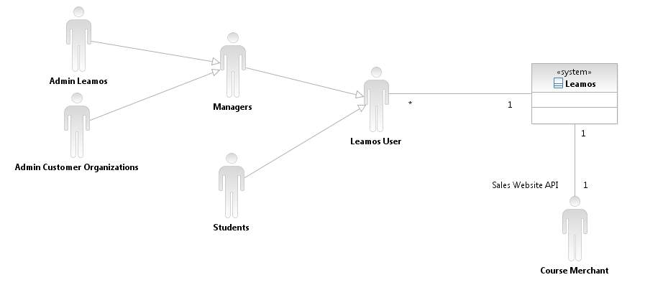

Figure 1: System Context Diagram for Leamos

Note : The Admin of Leamos and the Admins of customer organizations are generalized to one level of manager. As such there are no users who are managers but the admin of Leamos and customer organization have almost similar permissions. Some permissions are only limited to the admin of Leamos.

Table 1: Actors Summary

| **Actor** | **Description** | **Responsibilities** |
| --- | --- | --- |
| Users | Users are regular user which includes all the actors of the system i.e. Admin Leamos, Admin Customer Organizations, Students. | Users can perform all actions which are common between all the actors of the system like:   * Login * Logout * View Courses * View Lessons * Retrieve Password |
| Managers | Managers are users who will me managing Leamos. | Managers have actions common to both the Admin of Leamos and the Admins of customer organizations.   * Manage Students * Generate Progress Reports |
| Admin Leamos | Admin Leamos are a group of people who handle and run the organization Centro Latino for Literacy. | The responsibilities of the Leamos Administrators are:   * Manage Courses * Manage Student Profiles * Generate Progress Reports * Manage Customer profiles * Maintain Leamos. |
| Admin Customer Organization | Admin Customer Organizations are individuals or Organizations who purchase Leamos lessons from Centro Latino. | The responsibilities of the Customer Organizations are:   * Registers to Leamos * Selects Courses * Purchase Courses * Manage Student Profiles * Generate Progress Reports |
| Students | Non- literate Spanish speaking students who don’t know how to use a computer and other input devices. | The responsibilities of the Students are:   * Take Lessons * Login/Logout * Take tests |
| Course Merchant | Ecommerce application which allows the organization to sell courses online. | The responsibilities of course merchant are:   * To provide API's so the Sales Website can be integrated with an online payment system. |

##### Artifacts & Information

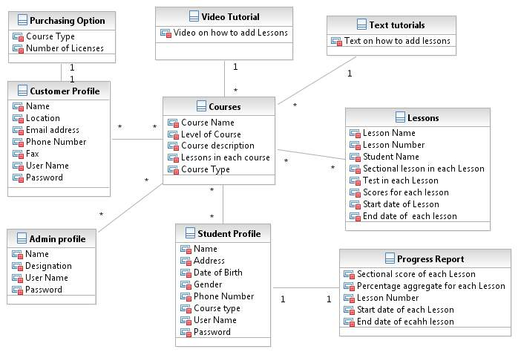

Figure 2: Artifacts and Information Diagram

Table 2: Artifacts and Information Summary

|  |  |
| --- | --- |
| **Artifact** | **Purpose** |
| ATF-1: Courses | Leamos Course contains lessons in form of HTML5 videos and other course details like:   * Course name. * Course Description * Lessons in each course. * Level of Course |
| ATF-2: Lessons | Lessons consists of:   * Sectional Lessons in each Lesson * Test for each Section * Start date for each Lesson * Completion date for each Lesson * Scores of each section * Student Name |
| ATF-3: Purchasing Information | Customers would be able to pay online through payment form. The payment information form will consists of the course and number of licenses customers wants to purchase. |
| ATF-4: Student Profile | Student profile form will contain customer details like:   * Name * Address * Date of birth * Gender * Phone Number * User Name * Password |
| ATF-5: Customer Profile | Customer profile form will contain customer details like :   * Name * Designation * Location * Email * Phone Number * Fax * User Name * Password * Agreement   And other details which would be required. |
| ATF-6: Purchasing Information | It would contain Information like Course type and number of licenses to be purchased by customers. |
| ATF-7: Text Tutorial | It will contain Lessons on how to add lessons to the system in the form of:   * Text |
| ATF:8 Video Tutorial | It will contain Lessons on how to add lessons to the system in the form of:   * Video |

##### Behavior

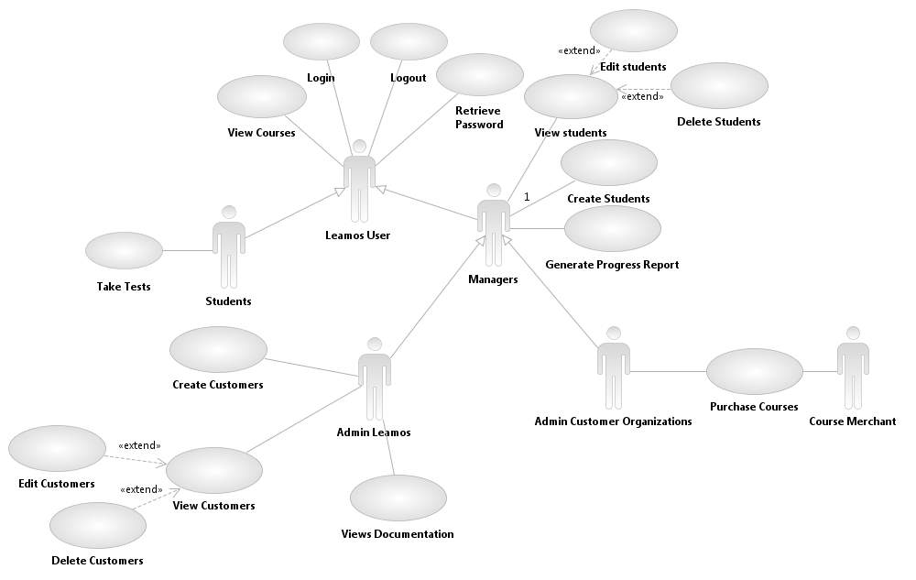

Figure : Process Diagram for Leamos

###### Authorization and Authentication

Login

Table 3: Process Description

|  |  |
| --- | --- |
| **Identifier** | UC-1: Login |
| **Purpose** | Allows users to access the lessons when they login. |
| **Requirements** | WC-725: Easy Login and Logout. |
| **Development Risks** | None |
| **Pre-conditions** | Registered User name and password in the database |
| **Post-conditions** | User is authorized to use Leamos Courses |

Table 4: Typical Course of Action

|  |  |  |
| --- | --- | --- |
| **Seq#** | **Actor’s Action** | **System’s Response** |
| **1** | [User] Enters Username and Password |  |
| **2** | [User] Clicks the Login button |  |
|  |  | Authenticate user name and password |
|  |  | Redirects the user to the current Leamos lesson |
| **3** | [User] Views lessons |  |

Table 5: Alternate Course of Action

|  |  |  |
| --- | --- | --- |
| **Seq#** | **Actor’s Action** | **System’s Response** |
| **1** | [User] Enters an invalid username and/or password |  |
| **2** | [User] Clicks the Login Button |  |
|  |  | Validates user name and password with the database |
|  |  | A dialogue box pops up with message "Incorrect user name or password" . |

Table 6: Process Description

|  |  |
| --- | --- |
| **Identifier** | UC-2: Logout |
| **Purpose** | Allows Users to Logout of the session |
| **Requirements** | WC-725: Easy Login and Logout. |
| **Development Risks** | None |
| **Pre-conditions** | User is logged in.  User session still exists. |
| **Post-conditions** | User session is terminated.  User cannot access the courses after logout. |

Table 7: Typical Course of Action

|  |  |  |
| --- | --- | --- |
| **Seq#** | **Actor’s Action** | **System’s Response** |
| **2** | [User] Clicks the Logout button |  |
|  |  | User session terminated. |

2.1.3.1.2 Retrieve Password

Table 8: Process Description

|  |  |
| --- | --- |
| **Identifier** | UC-3: Retrieve Password |
| **Purpose** | Allows a student to retrieve their password in case they've forgotten. |
| **Requirements** | WinCondition: 244 |
| **Development Risks** | Anyone can know the password is as password would be displayed on login screen itself according to client's requirement. |
| **Pre-conditions** | Registered User with Leamos.  User forgets the Password  Should have answer to security question. |
| **Post-conditions** | Password is displayed on Login screen and user can login again with correct password. |

Table 9: Typical Course of Action

|  |  |  |
| --- | --- | --- |
| **Seq#** | **Actor’s Action** | **System’s Response** |
| **1** | [User] Enters Username and Password |  |
| **2** | [User] Clicks the Login button |  |
|  |  | Validates user name and password with Database |
|  |  | Dialogue box pops us with message "Incorrect user name and password" |
| **3** | [User] Clicks on Forgot password recovery button |  |
|  |  | Displays security question and waits for answer |
| **4** | [User] Enters answer for security question |  |
|  |  | Authenticates the answer and displays the password |
| **5** | [User] Reads the password and clicks on login button |  |
|  |  | Authenticate user name and password |

2.1.3.2 Video Lessons

2.1.3.2.1 View Courses

Table 10: Process Description

|  |  |  |
| --- | --- | --- |
| **Identifier** | UC-4: View Courses | |
| **Purpose** | HTML5 lessons can be accessed anywhere with all the modern devices like tablets, smart phones etc. | |
| **Requirements** | | WC :478 |
| **Development Risks** | Improper implementation may lead to crashing of lessons. | |
| **Pre-conditions** | User should be logged in .  Lesson should be selected | |
| **Post-conditions** | Lessons taken by the user are marked as done or taken .  User can only now view the current lessons or previously taken lesson. | |

Table 11: Typical Course of Action

|  |  |  |
| --- | --- | --- |
| **Seq#** | **Actor’s Action** | **System’s Response** |
| **1** | [User] Selects the lesson |  |
|  |  | Validates with database if previous lessons are taken. |
|  |  | Lesson validated. |
|  |  | Required lesson starts running |

**Table 12**: **Alternate course of action**

|  |  |  |
| --- | --- | --- |
| **Seq#** | **Actor’s Action** | **System’s Response** |
| **1** | [User] Selects the lesson |  |
| **2** |  | Validates with database if previous Lessons are taken. |
|  |  | Validation Fails. |
|  |  | A dialogue box pops up with message "You cannot jump to next lesson until you finish previous ones". |

**2.1.3.2.2** **Take Tests**

Table 13: Process Description

|  |  |  |
| --- | --- | --- |
| Identifier | UC-5: Give Tests | |
| Purpose | Record performance of students | |
| Requirements | | WC: 478 |
| Development Risks | Incorrect embedding of videos may lead to inaccessibility of lessons to students. | |
| Pre-conditions | Student should complete each section of the lesson.  Student should take the test.  Students should have finished the tests. | |
| Post-conditions | Scores are recorded to generate progress reports for each section of each lesson | |

Table 14: Typical Course of Action

|  |  |  |
| --- | --- | --- |
| **Seq#** | **Actor’s Action** | **System’s Response** |
| **1** | [Student] Take the test |  |
|  |  | Records answers for each section |
|  |  | Generate scores reports for each section of each lesson. |

**Table 15**: Alternate course of action

|  |  |  |
| --- | --- | --- |
| **Seq#** | **Actor’s Action** | **System’s Response** |
| **1** | [User] Skips the test |  |
|  |  | A dialogue box pops up with message "You cannot jump to next section until you complete the test". |

* + - 1. Sales Website

**2.1.3.3.1 Purchase Courses**

Table 16: Process Description

|  |  |
| --- | --- |
| **Identifier** | UC-6: Purchase Courses |
| **Purpose** | Used by customers to purchase a course |
| **Requirements** | WC: 245 |
| **Development Risks** | Interfacing sales website with Course Merchant is a big risk. |
| **Pre-conditions** | Should be registered Customer of Centro Latino for Literacy.  Customer should select purchasing options. |
| **Post-conditions** | Customer purchases courses.  Manages their own students. |

Table 17: Typical Course of Action

|  |  |  |
| --- | --- | --- |
| **Seq#** | **Actor’s Action** | **System’s Response** |
| **1** | [Customer] Clicks on view Course list |  |
|  |  | Display list of courses along with payment amount |
| **2** | [Customer] Clicks on purchasing options |  |
|  |  | Displays purchasing options |
|  |  | Select Courses and number of licenses. |
| **3** | [Customer]Selects purchasing options |  |
|  |  | Displays final course and number of licenses to be purchased |
|  | [Customer] Clicks on Buy button |  |
|  |  | Connect to Course Merchant for e-payment and ask for details of payment |
|  | [Customer] Enters payment details |  |
|  |  | Verifies and authenticates payment details |
|  |  | Displays "Successful Payment" dialogue box. |

**2.1.3.4 Profile Management**

**2.1.3.4.1 Manage Student Profile**

Table 18: Process Description

|  |  |
| --- | --- |
| **Identifier** | UC-7: Create student |
| **Purpose** | The purpose for this is that the Admins of Leamos and Customer can Create new student profile in the system. |
| **Requirements** | Win Condition 245: Student management |
| **Development Risks** | Incorrect Mapping of student information. |
| **Pre-conditions** | User should have admin access.  User should have the student’s details. |
| **Post-conditions** | Student profile is created.  Data is stored in database or deleted from database. |

Table 19: Typical Course of Action

|  |  |  |
| --- | --- | --- |
| **Seq#** | **Actor’s Action** | **System’s Response** |
| **1** | [Managers] Creates Students |  |
|  |  | Create Student login and add student details to the database. |
|  |  | Student information is added to the Database. |
|  |  | Dialogue box prompts with message ”Student Profile created” |

Table 20: Process Description

|  |  |
| --- | --- |
| **Identifier** | UC-8: View student |
| **Purpose** | The purpose for this is that the Admins of Leamos and Admin of Customer organization to edit or delete student information. |
| **Requirements** | Win Condition 245: Student management |
| **Development Risks** | None |
| **Pre-conditions** | User should have admin access.  User should have the student’s details. |
| **Post-conditions** | Student profile is edited / deleted.  Data is stored in database or deleted from database. |

Table 21: Typical Course of Action

|  |  |  |
| --- | --- | --- |
| **Seq#** | **Actor’s Action** | **System’s Response** |
| **1** | [Managers] View Student profile |  |
|  |  | Displays student profile |
| **2** | [Managers]edit Student profile. |  |
|  |  | Student profile update. |
| **3** | [Managers]delete Student profile |  |
|  |  | Student Profile deleted. |

Table 22: Process Description

**2.1.3.4.2 Manage Customers**

|  |  |
| --- | --- |
| **Identifier** | UC-9: Create Customer |
| **Purpose** | The purpose for this is that the Admins of Leamos can Create new Customer profile in the system. |
| **Requirements** | Win Condition 245: Customer management |
| **Development Risks** | Incorrect Mapping of Customer information. |
| **Pre-conditions** | User should have admin access.  User should have the customer details. |
| **Post-conditions** | Customer profile is created.  Data is stored in database or deleted from database. |

Table 23: Typical Course of Action

|  |  |  |
| --- | --- | --- |
| **Seq#** | **Actor’s Action** | **System’s Response** |
| **1** | [Admin Leamos] Creates Customer |  |
|  |  | Create Customer and add student details to the database. |
|  |  | Dialogue box prompts with message ”customer Profile created” |

Table 24: Process Description

|  |  |
| --- | --- |
| **Identifier** | UC-10: View Customer |
| **Purpose** | The purpose for this is that the Admins of Leamos to edit or delete Customer information. |
| **Requirements** | Win Condition 245: Customer management |
| **Development Risks** | None |
| **Pre-conditions** | User should have admin access.  User should have the Customer details. |
| **Post-conditions** | Customer profile is edited / deleted.  Data is stored in database or deleted from database. |

Table 25: Typical Course of Action

|  |  |  |
| --- | --- | --- |
| **Seq#** | **Actor’s Action** | **System’s Response** |
| **1** | [Admin Leamos] View Customer profile |  |
|  |  | Displays Customer profile |
| **2** | [Admin Leamos]edit Customer profile. |  |
|  |  | Customer profile update. |
| **3** | [Admin Leamos delete Cutomer profile |  |
|  |  | Customer Profile deleted. |

**2.1.3.4.3 Generate Progress Reports**

Table 26: Process Description

|  |  |
| --- | --- |
| **Identifier** | UC-11:Generate Progress Report |
| **Purpose** | Admins of Leamos and Customers’ Organizations can Generate Progress reports of students |
| **Requirements** | Win Condition 245: Generate Progress Report |
| **Development Risks** | None |
| **Pre-conditions** | Students should have given the tests.  Record of scores in database. |
| **Post-conditions** | Progress report with percentage aggregate for each section of lessons. |

Table 27: Typical Course of Action

|  |  |  |
| --- | --- | --- |
| **Seq#** | **Actor’s Action** | **System’s Response** |
| **1** | [Managers] Records Students Score for each lesson. |  |
|  |  | Student Scores are inserted into the database |
|  |  | Student progress report is generated |

2.1.3.5 Adding lessons and Documentation

**2.1.3.5.1 View Documentation**

Table 28: Process Description

|  |  |
| --- | --- |
| **Identifier** | UC-12: View Documentation |
| **Purpose** | Adds new lessons and document the same so that in the future anyone can add new videos |
| **Requirements** | Win Condition 986: Add new lessons and document |
| **Development Risks** | Lessons will be added if steps are not demonstrated . |
| **Pre-conditions** | Developer adds lessons and documents the steps to add lessons |
| **Post-conditions** | The new videos are available online.  Centro Latino staff can now add lessons with help of tutorials. |

Table 29: Typical Course of Action

|  |  |  |
| --- | --- | --- |
| **Seq#** | **Actor’s Action** | **System’s Response** |
| **1** | [Admin Leamos] Reads or watches videos on how to add Lessons. |  |
|  |  | Videos added to the system |
|  |  | The new video is displayed |
|  |  | Videos added to the system |
|  |  | The new video is displayed |

### NDI/NCS Interoperability Analysis

#### Introduction

The NDI's and NCS for our system are:

**1.) NDI**:

Application NDI : The application NDI used in our system are Adobe wallaby to convert flash files to HTML5 format.

System NDI**:** Leamos uses Language NDI's like PHP 4.3.0, HTML5, which are language NDI's. Database like NDI's MySQL 4.1.16 to store database of Leamos students, staff and customer organizations, Apache as Server NDI.

**2.)NCS:** E-learning system such as Moodle 1.9 is used as the main NCS on which the whole system will be deployed, payment services like course merchant will be used to make payment for the customer organizations.

##### COTS / GOTS / ROTS / Open Source / NCS

Table 22: NDI Products Listing

|  |  |
| --- | --- |
| **NDI/NCS Products** | **Purposes** |
| Moodle 1.9 Platform | e-learning content management system |
| Course Merchant | Payment service NCS to make payment for customer organizations. |
| Course merchant API's | COTS which will be used to integrate website with course merchant. |
| MySQL 4.1.16 | It will be used as database system for Moodle. |
| Apache | Web server |
| Adobe wallaby | To convert flash files to HTML5. |
| PHP 4.3.0 | To make website pages and to connect website to the database. |

Note: Moodle supports IE 9 , Google Chrome 15.0 , Safari 5.1.1, FireFox 8.0.1 , Opera Mini Web Browser , Skyfire 2.0 and operating systems Windows , Android , Mac os , iOS , BlackBerry OS , Windows Mobile .

##### Connectors

Leamos is built on the Moodle platform which is built on PHP and the back end is MySQL. Hence in order to tweak the existing code and extend the functionality of Leamos, we will be using PHP and MySQL. Also, Leamos will be integrated with a third party merchant system (Course Merchant), which will provide us the APIs to connect our code with the Course Merchant System.

##### Legacy System

The system should be supporting Moodle 1.9 as the whole system is deployed on this Moodle version. Also, Leamos is already running on Moodle 1.9.

#### System Structure

**3.2.1 Hardware Component model**

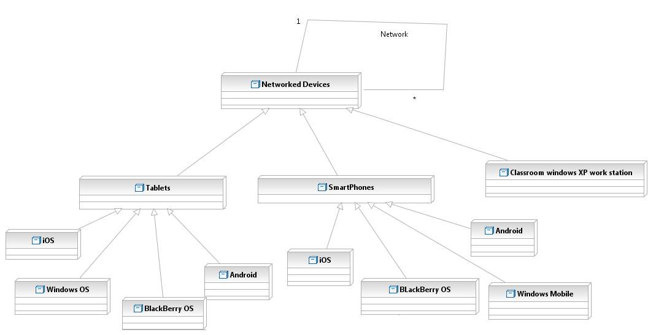

Figure 4: Hardware component diagram

**3.2.1 Software Components**

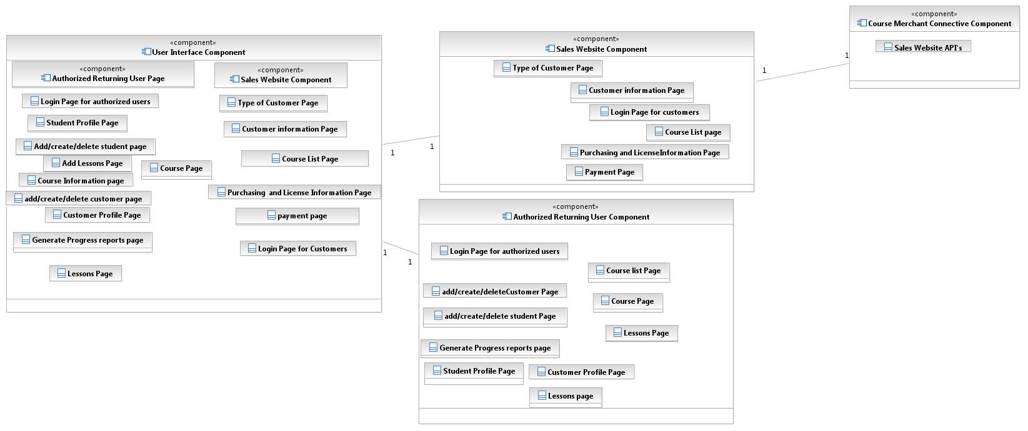

Figure 5: Software Component Diagram

**3.2.3 Deployment Diagram**

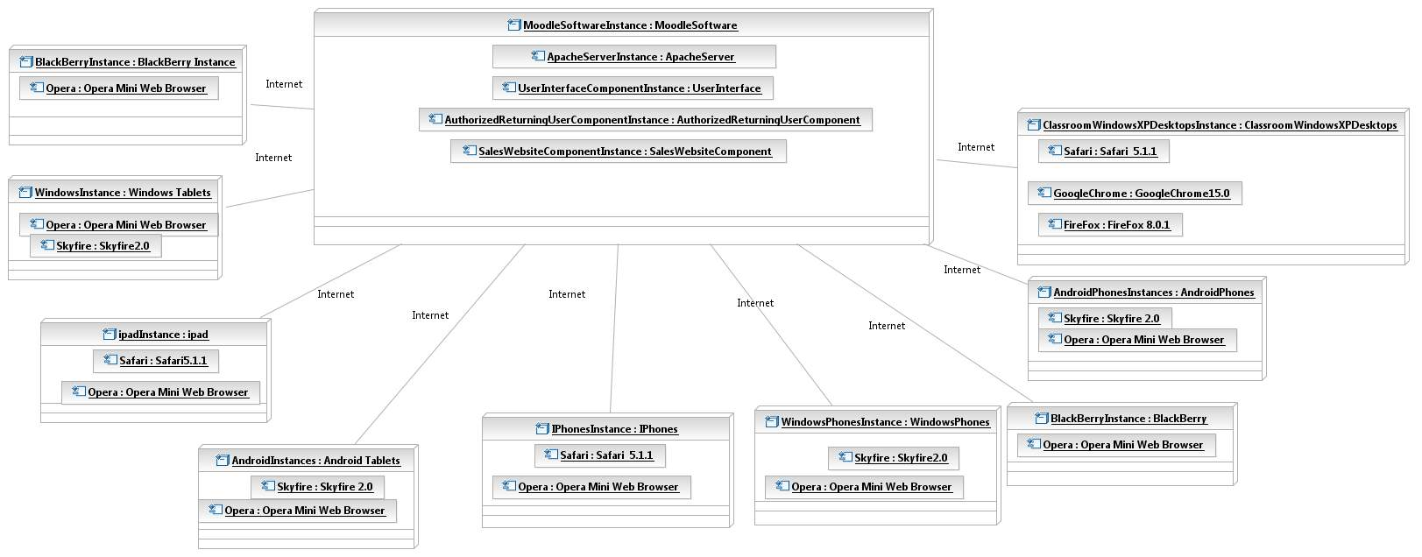

Figure 6: Deployment Diagram

#### Evaluation Summary

Table 23: NDI Evaluation

|  |  |  |
| --- | --- | --- |
| **NDI/NCS Products** | **Purposes** | **Comments** |
| Moodle 1.9 Platform | e-learning content management system | * Selected by client since it's user friendly. * Leamos is already running on this platform. * Free to use. * easy to use as most of the functionalities are already provided |
| Course Merchant | Payment service NCS to make payment for customer organizations. | * automatic account creation for customers * reliable and fast transaction * paid service. |
| MySQL 4.1.16 | It would be used as database system for Moodle. | * open source database engine. * known for performance |
| Apache | Web server | * open source * reliable and portable * supports wide range of community |
| Adobe wallaby | To convert flash files to HTML5. | * free software * only converts flv files to HTML5 not swf. |
| PHP 4.3.0 | To make webpages and to connect the website to the database. | * known languages for most of the team members * fast, secure, reliable. |